**ABSTRACT**

Due to the rise and rapid growth of E-Commerce, use of credit cards for online purchases has dramatically increased and it caused an explosion in the credit card fraud. As credit card becomes the most popular mode of payment for both online as well as regular purchase, cases of fraud associated with it are also rising.

Our project Credit card fraud detection presents a survey of various techniques used in credit card fraud detection mechanisms and evaluates each methodology based on certain design criteria. Fraudulent transactions are scattered with genuine transactions and simple pattern matching techniques are not often sufficient to detect those frauds accurately. Implementation of efficient fraud detection systems has thus become imperative for all credit card issuing banks to minimize their losses. Many modern techniques based on Artificial Intelligence, Data mining, Fuzzy logic, Machine learning, Sequence Alignment, Genetic Programming etc., has evolved in detecting various credit card fraudulent transactions. A clear understanding on all these approaches will certainly lead to an efficient credit card fraud detection system.

**1.1 IMPLEMENTATION**

**MODULES:**

* User Module
* Admin Module

**MODULES DESCSRIPTION:**

**User:**

User need to give all the detail in the registration form to get registered with the application. User can get login with a valid username and password. User can add card details and can add money in the card. User can view the details of the money available in his card. User can view all the products available in the application and can purchase the products.

**Admin:**

Admin can get login by entering unique username and password.

Admin will add all the details of the products.Admin can view the details of the fraud users and can block them if necessary.

**SYSTEM FEASIBILITY**

**2.1 EXISTING SYSTEM**:

The Traditional detection method mainly depends on database system and the education of customers, which usually are delayed, inaccurate and not in-time. After that methods based on discriminate analysis and regression analysis are widely used which can detect fraud by credit rate for cardholders and credit card transaction for a large amount of data it is not efficient.

**2.2 PROPOSED SYSTEM:**

In the proposed system, high amount of losses due to fraud and the awareness of the relation between loss and the available limit have to be reduced. Number of fraud will be deducted and the number of false alert has to be minimized which consumes less time and takes no physical effort. The fraud is detected based on the customer’s behavior. A new classification problem which has a variable misclassification cost is introduced.

**SYSTEM ANALYSIS**

**3.1 THE STUDY OF THE SYSTEM**

* To conduct studies and analyses of an operational and technological nature, and
* To promote the exchange and development of methods and tools for operational analysis as applied to defense problems.

Logical design

The logical design of a system pertains to an abstract representation of the data flows, inputs and outputs of the system. This is often conducted via modeling, using an over-abstract (and sometimes graphical) model of the actual system. In the context of systems design are included. Logical design includes ER Diagrams i.e. Entity Relationship Diagrams

Physical design

The physical design relates to the actual input and output processes of the system. This is laid down in terms of how data is input into a system, how it is verified / authenticated, how it is processed, and how it is displayed as output. In Physical design, following requirements about the system are decided.

1. Input requirement,
2. Output requirements,
3. Storage requirements,
4. Processing Requirements,
5. System control and backup or recovery.

Put another way, the physical portion of systems design can generally be broken down into three sub-tasks:

1. User Interface Design
2. Data Design
3. Process Design

User Interface Design is concerned with how users add information to the system and with how the system presents information back to them. Data Design is concerned with how the data is represented and stored within the system. Finally, Process Design is concerned with how data moves through the system, and with how and where it is validated, secured and/or transformed as it flows into, through and out of the system. At the end of the systems design phase, documentation describing the three sub-tasks is produced and made available for use in the next phase.

Physical design, in this context, does not refer to the tangible physical design of an information system. To use an analogy, a personal computer's physical design involves input via a keyboard, processing within the CPU, and output via a monitor, printer, etc. It would not concern the actual layout of the tangible hardware, which for a PC would be a monitor, CPU, motherboard, hard drive, modems, video/graphics cards, USB slots, etc. It involves a detailed design of a user and a product database structure processor and a control processor. The H/S personal specification is developed for the proposed system.

**3.2** **INPUT & OUTPUT REPRESENTATION**

Input Design

The input design is the link between the information system and the user. It comprises the developing specification and procedures for data preparation and those steps are necessary to put transaction data in to a usable form for processing can be achieved by inspecting the computer to read data from a written or printed document or it can occur by having people keying the data directly into the system. The design of input focuses on controlling the amount of input required, controlling the errors, avoiding delay, avoiding extra steps and keeping the process simple. The input is designed in such a way so that it provides security and ease of use with retaining the privacy. Input Design considered the following things:

* What data should be given as input?
* How the data should be arranged or coded?
* The dialog to guide the operating personnel in providing input.
* Methods for preparing input validations and steps to follow when error occur.

Objectives

Input Design is the process of converting a user-oriented description of the input into a computer-based system. This design is important to avoid errors in the data input process and show the correct direction to the management for getting correct information from the computerized system.

It is achieved by creating user-friendly screens for the data entry to handle large volume of data. The goal of designing input is to make data entry easier and to be free from errors. The data entry screen is designed in such a way that all the data manipulates can be performed. It also provides record viewing facilities.

When the data is entered it will check for its validity. Data can be entered with the help of screens. Appropriate messages are provided as when needed so that the user will not be in maize of instant. Thus the objective of input design is to create an input layout that is easy to follow

Output Design

A quality output is one, which meets the requirements of the end user and presents the information clearly. In any system results of processing are communicated to the users and to other system through outputs. In output design it is determined how the information is to be displaced for immediate need and also the hard copy output. It is the most important and direct source information to the user. Efficient and intelligent output design improves the system’s relationship to help user decision-making.

* 1. Designing computer output should proceed in an organized, well thought out manner; the right output must be developed while ensuring that each output element is designed so that people will find the system can use easily and effectively. When analysis design computer output, they should Identify the specific output that is needed to meet the requirements.
  2. Select methods for presenting information.
  3. Create document, report, or other formats that contain information produced by the system.

The output form of an information system should accomplish one or more of the following objectives.

* Convey information about past activities, current status or projections of the future.
* Signal important events, opportunities, problems, or warnings.
* Trigger an action.
* Confirm an action.

## 3.3 Java Technology

## Java Technology

Java technology is both a programming language and a platform.

### The Java Programming Language

### The Java programming language is a high-level language that can be characterized by all of the following buzzwords:

* + - Simple
    - Architecture neutral
    - Object oriented
    - Portable
    - Distributed
    - High performance
    - Interpreted
    - Multithreaded
    - Robust
    - Dynamic
    - Secure

With most programming languages, you either compile or interpret a program so that you can run it on your computer. The Java programming language is unusual in that a program is both compiled and interpreted. With the compiler, first you translate a program into an intermediate language called Java byte codes —the platform-independent codes interpreted by the interpreter on the Java platform. The interpreter parses and runs each Java byte code instruction on the computer. Compilation happens just once; interpretation occurs each time the program is executed. The following figure illustrates how this works.

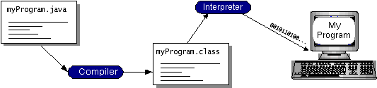

You can think of Java byte codes as the machine code instructions for the Java Virtual Machine (Java VM). Every Java interpreter, whether it’s a development tool or a Web browser that can run applets, is an implementation of the Java VM. Java byte codes help make “write once, run anywhere” possible. You can compile your program into byte codes on any platform that has a Java compiler. The byte codes can then be run on any implementation of the Java VM. That means that as long as a computer has a Java VM, the same program written in the Java programming language can run on Windows 2000, a Solaris workstation, or on an iMac.

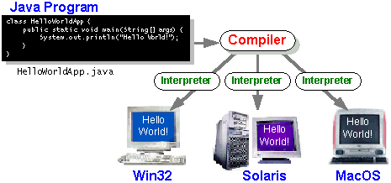

### The Java Platform

A platform is the hardware or software environment in which a program runs. We’ve already mentioned some of the most popular platforms like Windows 2000, Linux, Solaris, and MacOS. Most platforms can be described as a combination of the operating system and hardware. The Java platform differs from most other platforms in that it’s a software-only platform that runs on top of other hardware-based platforms.

The Java platform has two components:

* The Java Virtual Machine (Java VM)
* The Java Application Programming Interface (Java API)

You’ve already been introduced to the Java VM. It’s the base for the Java platform and is ported onto various hardware-based platforms.

The Java API is a large collection of ready-made software components that provide many useful capabilities, such as graphical user interface (GUI) widgets. The Java API is grouped into libraries of related classes and interfaces; these libraries are known as packages. The next section, What Can Java Technology Do? Highlights what functionality some of the packages in the Java API provide.

The following figure depicts a program that’s running on the Java platform. As the figure shows, the Java API and the virtual machine insulate the program from the hardware.

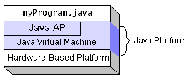

Native code is code that after you compile it, the compiled code runs on a specific hardware platform. As a platform-independent environment, the Java platform can be a bit slower than native code. However, smart compilers, well-tuned interpreters, and just-in-time byte code compilers can bring performance close to that of native code without threatening portability.

## What Can Java Technology Do?

The most common types of programs written in the Java programming language are applets and applications. If you’ve surfed the Web, you’re probably already familiar with applets. An applet is a program that adheres to certain conventions that allow it to run within a Java-enabled browser.

However, the Java programming language is not just for writing cute, entertaining applets for the Web. The general-purpose, high-level Java programming language is also a powerful software platform. Using the generous API, you can write many types of programs.

An application is a standalone program that runs directly on the Java platform. A special kind of application known as a server serves and supports clients on a network. Examples of servers are Web servers, proxy servers, mail servers, and print servers. Another specialized program is a servlet. A servlet can almost be thought of as an applet that runs on the server side. Java Servlets are a popular choice for building interactive web applications, replacing the use of CGI scripts. Servlets are similar to applets in that they are runtime extensions of applications. Instead of working in browsers, though, servlets run within Java Web servers, configuring or tailoring the server.

How does the API support all these kinds of programs? It does so with packages of software components that provides a wide range of functionality. Every full implementation of the Java platform gives you the following features:

* **The essentials**: Objects, strings, threads, numbers, input and output, data structures, system properties, date and time, and so on.
* **Applets**: The set of conventions used by applets.
* **Networking**: URLs, TCP (Transmission Control Protocol), UDP (User Data gram Protocol) sockets, and IP (Internet Protocol) addresses.
* **Internationalization**: Help for writing programs that can be localized for users worldwide. Programs can automatically adapt to specific locales and be displayed in the appropriate language.
* **Security**: Both low level and high level, including electronic signatures, public and private key management, access control, and certificates.
* **Software components**: Known as JavaBeansTM, can plug into existing component architectures.
* **Object serialization**: Allows lightweight persistence and communication via Remote Method Invocation (RMI).
* **Java Database Connectivity (JDBCTM)**: Provides uniform access to a wide range of relational databases.

The Java platform also has APIs for 2D and 3D graphics, accessibility, servers, collaboration, telephony, speech, animation, and more. The following figure depicts what is included in the Java 2 SDK.

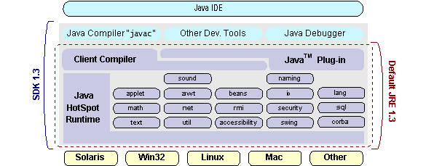

## How Will Java Technology Change My Life?

We can’t promise you fame, fortune, or even a job if you learn the Java programming language. Still, it is likely to make your programs better and requires less effort than other languages. We believe that Java technology will help you do the following:

* **Get started quickly**: Although the Java programming language is a powerful object-oriented language, it’s easy to learn, especially for programmers already familiar with C or C++.
* **Write less code**: Comparisons of program metrics (class counts, method counts, and so on) suggest that a program written in the Java programming language can be four times smaller than the same program in C++.
* **Write better code**: The Java programming language encourages good coding practices, and its garbage collection helps you avoid memory leaks. Its object orientation, its JavaBeans component architecture, and its wide-ranging, easily extendible API let you reuse other people’s tested code and introduce fewer bugs.
* **Develop programs more quickly**: Your development time may be as much as twice as fast versus writing the same program in C++. Why? You write fewer lines of code and it is a simpler programming language than C++.
* **Avoid platform dependencies with 100% Pure Java**: You can keep your program portable by avoiding the use of libraries written in other languages. The 100% Pure JavaTM Product Certification Program has a repository of historical process manuals, white papers, brochures, and similar materials online.
* **Write once, run anywhere**: Because 100% Pure Java programs are compiled into machine-independent byte codes, they run consistently on any Java platform.
* **Distribute software more easily**: You can upgrade applets easily from a central server. Applets take advantage of the feature of allowing new classes to be loaded “on the fly,” without recompiling the entire program.

### ODBC

Microsoft Open Database Connectivity (ODBC) is a standard programming interface for application developers and database systems providers. Before ODBC became a de facto standard for Windows programs to interface with database systems, programmers had to use proprietary languages for each database they wanted to connect to. Now, ODBC has made the choice of the database system almost irrelevant from a coding perspective, which is as it should be. Application developers have much more important things to worry about than the syntax that is needed to port their program from one database to another when business needs suddenly change.

Through the ODBC Administrator in Control Panel, you can specify the particular database that is associated with a data source that an ODBC application program is written to use. Think of an ODBC data source as a door with a name on it. Each door will lead you to a particular database. For example, the data source named Sales Figures might be a SQL Server database, whereas the Accounts Payable data source could refer to an Access database. The physical database referred to by a data source can reside anywhere on the LAN.

The ODBC system files are not installed on your system by Windows 95. Rather, they are installed when you setup a separate database application, such as SQL Server Client or Visual Basic 4.0. When the ODBC icon is installed in Control Panel, it uses a file called ODBCINST.DLL. It is also possible to administer your ODBC data sources through a stand-alone program called ODBCADM.EXE. There is a 16-bit and a 32-bit version of this program and each maintains a separate list of ODBC data sources.

From a programming perspective, the beauty of ODBC is that the application can be written to use the same set of function calls to interface with any data source, regardless of the database vendor. The source code of the application doesn’t change whether it talks to Oracle or SQL Server. We only mention these two as an example. There are ODBC drivers available for several dozen popular database systems. Even Excel spreadsheets and plain text files can be turned into data sources. The operating system uses the Registry information written by ODBC Administrator to determine which low-level ODBC drivers are needed to talk to the data source (such as the interface to Oracle or SQL Server). The loading of the ODBC drivers is transparent to the ODBC application program. In a client/server environment, the ODBC API even handles many of the network issues for the application programmer.

The advantages of this scheme are so numerous that you are probably thinking there must be some catch. The only disadvantage of ODBC is that it isn’t as efficient as talking directly to the native database interface. ODBC has had many detractors make the charge that it is too slow. Microsoft has always claimed that the critical factor in performance is the quality of the driver software that is used. In our humble opinion, this is true. The availability of good ODBC drivers has improved a great deal recently. And anyway, the criticism about performance is somewhat analogous to those who said that compilers would never match the speed of pure assembly language. Maybe not, but the compiler (or ODBC) gives you the opportunity to write cleaner programs, which means you finish sooner. Meanwhile, computers get faster every year.

**JDBC**

In an effort to set an independent database standard API for Java; Sun Microsystems developed Java Database Connectivity, or JDBC. JDBC offers a generic SQL database access mechanism that provides a consistent interface to a variety of RDBMSs. This consistent interface is achieved through the use of “plug-in” database connectivity modules, or drivers. If a database vendor wishes to have JDBC support, he or she must provide the driver for each platform that the database and Java run on.

To gain a wider acceptance of JDBC, Sun based JDBC’s framework on ODBC. As you discovered earlier in this chapter, ODBC has widespread support on a variety of platforms. Basing JDBC on ODBC will allow vendors to bring JDBC drivers to market much faster than developing a completely new connectivity solution.

JDBC was announced in March of 1996. It was released for a 90 day public review that ended June 8, 1996. Because of user input, the final JDBC v1.0 specification was released soon after.

The remainder of this section will cover enough information about JDBC for you to know what it is about and how to use it effectively. This is by no means a complete overview of JDBC. That would fill an entire book.

### JDBC Goals

Few software packages are designed without goals in mind. JDBC is one that, because of its many goals, drove the development of the API. These goals, in conjunction with early reviewer feedback, have finalized the JDBC class library into a solid framework for building database applications in Java.

The goals that were set for JDBC are important. They will give you some insight as to why certain classes and functionalities behave the way they do. The eight design goals for JDBC are as follows:

1. **SQL Level API**

The designers felt that their main goal was to define a SQL interface for Java. Although not the lowest database interface level possible, it is at a low enough level for higher-level tools and APIs to be created. Conversely, it is at a high enough level for application programmers to use it confidently. Attaining this goal allows for future tool vendors to “generate” JDBC code and to hide many of JDBC’s complexities from the end user.

1. **SQL Conformance**

SQL syntax varies as you move from database vendor to database vendor. In an effort to support a wide variety of vendors, JDBC will allow any query statement to be passed through it to the underlying database driver. This allows the connectivity module to handle non-standard functionality in a manner that is suitable for its users.

1. **JDBC must be implemental on top of common database interfaces**   
    The JDBC SQL API must “sit” on top of other common SQL level APIs. This goal allows JDBC to use existing ODBC level drivers by the use of a software interface. This interface would translate JDBC calls to ODBC and vice versa.
2. **Provide a Java interface that is consistent with the rest of the Java system**

Because of Java’s acceptance in the user community thus far, the designers feel that they should not stray from the current design of the core Java system.

1. **Keep it simple**

This goal probably appears in all software design goal listings. JDBC is no exception. Sun felt that the design of JDBC should be very simple, allowing for only one method of completing a task per mechanism. Allowing duplicate functionality only serves to confuse the users of the API.

1. **Use strong, static typing wherever possible**

Strong typing allows for more error checking to be done at compile time; also, less error appear at runtime.

1. **Keep the common cases simple**

Because more often than not, the usual SQL calls used by the programmer are simple SELECT’s, INSERT’s, DELETE’s and UPDATE’s, these queries should be simple to perform with JDBC. However, more complex SQL statements should also be possible.

Finally we decided to proceed the implementation using Java Networking.

And for dynamically updating the cache table we go for MS Access database.

Java ha two things: a programming language and a platform.

Java is a high-level programming language that is all of the following

Simple Architecture-neutral

Object-oriented Portable

Distributed High-performance

Interpreted multithreaded

Robust Dynamic

Secure

Java is also unusual in that each Java program is both compiled and interpreted. With a compile you translate a Java program into an intermediate language called Java byte codes the platform-independent code instruction is passed and run on the computer.

Compilation happens just once; interpretation occurs each time the program is executed. The figure illustrates how this works.

**Java Program**

**Compilers**

**Interpreter**

**My Program**

You can think of Java byte codes as the machine code instructions for the Java Virtual Machine (Java VM). Every Java interpreter, whether it’s a Java development tool or a Web browser that can run Java applets, is an implementation of the Java VM. The Java VM can also be implemented in hardware.

Java byte codes help make “write once, run anywhere” possible. You can compile your Java program into byte codes on my platform that has a Java compiler. The byte codes can then be run any implementation of the Java VM. For example, the same Java program can run Windows NT, Solaris, and Macintosh.

## Networking

### TCP/IP stack

The TCP/IP stack is shorter than the OSI one:

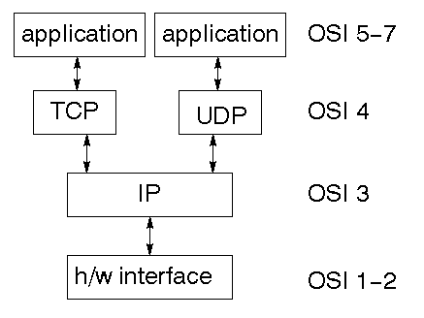

TCP is a connection-oriented protocol; UDP (User Datagram Protocol) is a connectionless protocol.

### IP datagram’s

The IP layer provides a connectionless and unreliable delivery system. It considers each datagram independently of the others. Any association between datagram must be supplied by the higher layers. The IP layer supplies a checksum that includes its own header. The header includes the source and destination addresses. The IP layer handles routing through an Internet. It is also responsible for breaking up large datagram into smaller ones for transmission and reassembling them at the other end.

### UDP

UDP is also connectionless and unreliable. What it adds to IP is a checksum for the contents of the datagram and port numbers. These are used to give a client/server model - see later.

### TCP

TCP supplies logic to give a reliable connection-oriented protocol above IP. It provides a virtual circuit that two processes can use to communicate.

### Internet addresses

In order to use a service, you must be able to find it. The Internet uses an address scheme for machines so that they can be located. The address is a 32 bit integer which gives the IP address. This encodes a network ID and more addressing. The network ID falls into various classes according to the size of the network address.

### Network address

Class A uses 8 bits for the network address with 24 bits left over for other addressing. Class B uses 16 bit network addressing. Class C uses 24 bit network addressing and class D uses all 32.

### Subnet address

Internally, the UNIX network is divided into sub networks. Building 11 is currently on one sub network and uses 10-bit addressing, allowing 1024 different hosts.

### Host address

8 bits are finally used for host addresses within our subnet. This places a limit of 256 machines that can be on the subnet.

### Total address

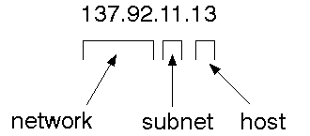

The 32 bit address is usually written as 4 integers separated by dots.

### Port addresses

A service exists on a host, and is identified by its port. This is a 16 bit number. To send a message to a server, you send it to the port for that service of the host that it is running on. This is not location transparency! Certain of these ports are "well known".

### Sockets

A socket is a data structure maintained by the system to handle network connections. A socket is created using the call socket. It returns an integer that is like a file descriptor. In fact, under Windows, this handle can be used with Read File and Write File functions.

#include <sys/types.h>

#include <sys/socket.h>

int socket(int family, int type, int protocol);

Here "family" will be AF_INET for IP communications, protocol will be zero, and type will depend on whether TCP or UDP is used. Two processes wishing to communicate over a network create a socket each. These are similar to two ends of a pipe - but the actual pipe does not yet exist.

**JFree Chart**

JFreeChart is a free 100% Java chart library that makes it easy for developers to display professional quality charts in their applications. JFreeChart's extensive feature set includes:

A consistent and well-documented API, supporting a wide range of chart types;

A flexible design that is easy to extend, and targets both server-side and client-side applications;

Support for many output types, including Swing components, image files (including PNG and JPEG), and vector graphics file formats (including PDF, EPS and SVG);

JFreeChart is "open source" or, more specifically, free software. It is distributed under the terms of the GNU Lesser General Public Licence (LGPL), which permits use in proprietary applications.

## 1. Map Visualizations

Charts showing values that relate to geographical areas. Some examples include: (a) population density in each state of the United States, (b) income per capita for each country in Europe, (c) life expectancy in each country of the world. The tasks in this project include:

Sourcing freely redistributable vector outlines for the countries of the world, states/provinces in particular countries (USA in particular, but also other areas);

Creating an appropriate dataset interface (plus default implementation), a rendered, and integrating this with the existing XYPlot class in JFreeChart;

Testing, documenting, testing some more, documenting some more.

## 2. Time Series Chart Interactivity

Implement a new (to JFreeChart) feature for interactive time series charts --- to display a separate control that shows a small version of ALL the time series data, with a sliding "view" rectangle that allows you to select the subset of the time series data to display in the main chart.

## 3. Dashboards

There is currently a lot of interest in dashboard displays. Create a flexible dashboard mechanism that supports a subset of JFreeChart chart types (dials, pies, thermometers, bars, and lines/time series) that can be delivered easily via both Java Web Start and an applet.

## 4. Property Editors

The property editor mechanism in JFreeChart only handles a small subset of the properties that can be set for charts. Extend (or reimplement) this mechanism to provide greater end-user control over the appearance of the charts.

**J2ME (Java 2 Micro edition):-**

Sun Microsystems defines J2ME as "a highly optimized Java run-time environment targeting a wide range of consumer products, including pagers, cellular phones, screen-phones, digital set-top boxes and car navigation systems." Announced in June 1999 at the JavaOne Developer Conference, J2ME brings the cross-platform functionality of the Java language to smaller devices, allowing mobile wireless devices to share applications. With J2ME, Sun has adapted the Java platform for consumer products that incorporate or are based on small computing devices.

**1. General J2ME architecture**



J2ME uses configurations and profiles to customize the Java Runtime Environment (JRE). As a complete JRE, J2ME is comprised of a configuration, which determines the JVM used, and a profile, which defines the application by adding domain-specific classes. The configuration defines the basic run-time environment as a set of core classes and a specific JVM that run on specific types of devices. We'll discuss configurations in detail in the The profile defines the application; specifically, it adds domain-specific classes to the J2ME configuration to define certain uses for devices. We'll cover profiles in depth in the The following graphic depicts the relationship between the different virtual machines, configurations, and profiles. It also draws a parallel with the J2SE API and its Java virtual machine. While the J2SE virtual machine is generally referred to as a JVM, the J2ME virtual machines, KVM and CVM, are subsets of JVM. Both KVM and CVM can be thought of as a kind of Java virtual machine -- it's just that they are shrunken versions of the J2SE JVM and are specific to J2ME.

**2. Developing J2ME applications**

Introduction In this section, we will go over some considerations you need to keep in mind when developing applications for smaller devices. We'll take a look at the way the compiler is invoked when using J2SE to compile J2ME applications. Finally, we'll explore packaging and deployment and the role preverification plays in this process.

**3. Design considerations for small devices**

Developing applications for small devices requires you to keep certain strategies in mind during the design phase. It is best to strategically design an application for a small device before you begin coding. Correcting the code because you failed to consider all of the "gotchas" before developing the application can be a painful process. Here are some design strategies to consider:

* Keep it simple. Remove unnecessary features, possibly making those features a separate, secondary application.

* Smaller is better. This consideration should be a "no brainer" for all developers. Smaller applications use less memory on the device and require shorter installation times. Consider packaging your Java applications as compressed Java Archive (jar) files.

* Minimize run-time memory use. To minimize the amount of memory used at run time, use scalar types in place of object types. Also, do not depend on the garbage collector. You should manage the memory efficiently yourself by setting object references to null when you are finished with them. Another way to reduce run-time memory is to use lazy instantiation, only allocating objects on an as-needed basis. Other ways of reducing overall and peak memory use on small devices are to release resources quickly, reuse objects, and avoid exceptions.

**4. Configurations overview**

The configuration defines the basic run-time environment as a set of core classes and a specific JVM that run on specific types of devices. Currently, two configurations exist for J2ME, though others may be defined in the future:

* **Connected Limited Device Configuration (CLDC)** is used specifically with the KVM for 16-bit or 32-bit devices with limited amounts of memory. This is the configuration (and the virtual machine) used for developing small J2ME applications. Its size limitations make CLDC more interesting and challenging (from a development point of view) than CDC. CLDC is also the configuration that we will use for developing our drawing tool application. An example of a small wireless device running small applications is a Palm hand-held computer.

* **Connected Device Configuration (CDC)** is used with the C virtual machine (CVM) and is used for 32-bit architectures requiring more than 2 MB of memory. An example of such a device is a Net TV box.

**5. J2ME profiles**

**What is a J2ME profile?**

As we mentioned earlier in this tutorial, a profile defines the type of device supported. The Mobile Information Device Profile (MIDP), for example, defines classes for cellular phones. It adds domain-specific classes to the J2ME configuration to define uses for similar devices. Two profiles have been defined for J2ME and are built upon CLDC: KJava and MIDP. Both KJava and MIDP are associated with CLDC and smaller devices. Profiles are built on top of configurations. Because profiles are specific to the size of the device (amount of memory) on which an application runs, certain profiles are associated with certain configurations.

A skeleton profile upon which you can create your own profile, the Foundation Profile, is available for CDC.

**Profile 1: KJava**

KJava is Sun's proprietary profile and contains the KJava API. The KJava profile is built on top of the CLDC configuration. The KJava virtual machine, KVM, accepts the same byte codes and class file format as the classic J2SE virtual machine. KJava contains a Sun-specific API that runs on the Palm OS. The KJava API has a great deal in common with the J2SE Abstract Windowing Toolkit (AWT). However, because it is not a standard J2ME package, its main package is com.sun.kjava. We'll learn more about the KJava API later in this tutorial when we develop some sample applications.

**Profile 2: MIDP**

MIDP is geared toward mobile devices such as cellular phones and pagers. The MIDP, like KJava, is built upon CLDC and provides a standard run-time environment that allows new applications and services to be deployed dynamically on end user devices. MIDP is a common, industry-standard profile for mobile devices that is not dependent on a specific vendor. It is a complete and supported foundation for mobile application

development. MIDP contains the following packages, the first three of which are core CLDC packages, plus three MIDP-specific packages.

* java.lang

* java.io

* java.util

* javax.microedition.io

* javax.microedition.lcdui

* javax.microedition.midlet

* javax.microedition.rms

**3.4** **SYSTEM REQUIREMENTS**

**3.4.1 HARDWARE REQUIREMENTS:**

* System : Pentium IV 2.4 GHz.
* Hard Disk : 200 GB.
* Floppy Drive : 1.44 Mb.
* Monitor : 15 VGA Colour.
* Mouse : Logitech.
* Ram : 1 GB.

**3.4.2 SOFTWARE REQUIREMENTS:**

* Operating system : Windows XP/7.
* Coding Language : Java
* Tool : Netbeans
* Database : MYSQL

.

**CHAPTER: 4**

**SYSTEM DESIGN**

**SYSTEM DESIGN**

System Design Introduction:

The System Design Document describes the system requirements, operating environment, system and subsystem architecture, files and database design, input formats, output layouts, human-machine interfaces, detailed design, processing logic, and external interfaces.

**4.1 UML DIAGRAMS**

Global Use Case Diagrams:

Identification of actors:

Actor: Actor represents the role a user plays with respect to the system. An actor interacts with, but has no control over the use cases.

Graphical representation:

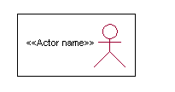

<<Actor name>>

An actor is someone or something that:

Interacts with or uses the system.

* Provides input to and receives information from the system.
* Is external to the system and has no control over the use cases.

Actors are discovered by examining:

* Who directly uses the system?
* Who is responsible for maintaining the system?
* External hardware used by the system.
* Other systems that need to interact with the system.

Questions to identify actors:

* + Who is using the system? Or, who is affected by the system? Or, which groups need help from the system to perform a task?
  + Who affects the system? Or, which user groups are needed by the system to perform its functions? These functions can be both main functions and secondary functions such as administration.
  + Which external hardware or systems (if any) use the system to perform tasks?
  + What problems does this application solve (that is, for whom)?
  + And, finally, how do users use the system (use case)? What are they doing with the system?

The actors identified in this system are:

1. System Administrator
2. Customer
3. Customer Care

Identification of usecases:

Usecase: A use case can be described as a specific way of using the system from a user’s (actor’s) perspective.

Graphical representation:



A more detailed description might characterize a use case as:

* Pattern of behavior the system exhibits
* A sequence of related transactions performed by an actor and the system
* Delivering something of value to the actor

Use cases provide a means to:

* capture system requirements
* communicate with the end users and domain experts
* test the system

Use cases are best discovered by examining the actors and defining what the actor will be able to do with the system.

Guide lines for identifying use cases:

* For each actor, find the tasks and functions that the actor should be able to perform or that the system needs the actor to perform. The use case should represent a course of events that leads to clear goal
* Name the use cases.
* Describe the use cases briefly by applying terms with which the user is familiar.

This makes the description less ambiguous

Questions to identify use cases:

* What are the tasks of each actor?
* Will any actor create, store, change, remove or read information in the system?
* What use case will store, change, remove or read this information?
* Will any actor need to inform the system about sudden external changes?
* Does any actor need to inform about certain occurrences in the system?
* What usecases will support and maintains the system?

1.2 **Flow of Events**

A flow of events is a sequence of transactions (or events) performed by the system. They typically contain very detailed information, written in terms of what the system should do, not how the system accomplishes the task. Flow of events are created as separate files or documents in your favorite text editor and then attached or linked to a use case using the Files tab of a model element.

A flow of events should include:

* When and how the use case starts and ends
* Use case/actor interactions
* Data needed by the use case
* Normal sequence of events for the use case
* Alternate or exceptional flows

**4.1.1 Construction of Usecase diagrams:**

A use case diagram in the Unified Modeling Language (UML) is a type of behavioral diagram defined by and created from a Use-case analysis. Its purpose is to present a graphical overview of the functionality provided by a system in terms of actors, their goals (represented as use cases), and any dependencies between those use cases. The main purpose of a use case diagram is to show what system functions are performed for which actor. Roles of the actors in the system can be depicted.

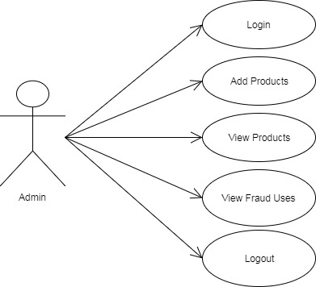

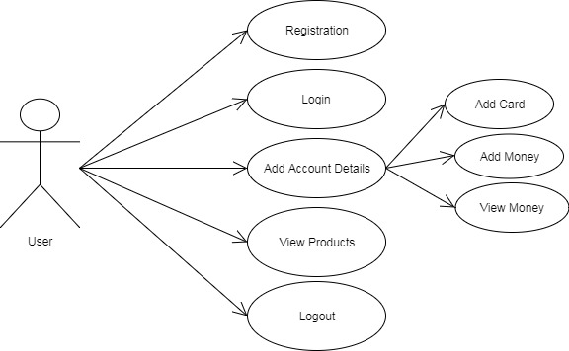

Figure 4.1.1 Use Case Diagram

**4.1.2 SEQUENCE DIAGRAMS:**

A sequence diagram in Unified Modeling Language (UML) is a kind of interaction diagram that shows how processes operate with one another and in what order. It is a construct of a Message Sequence Chart. Sequence diagrams are sometimes called event diagrams, event scenarios, and timing diagrams.

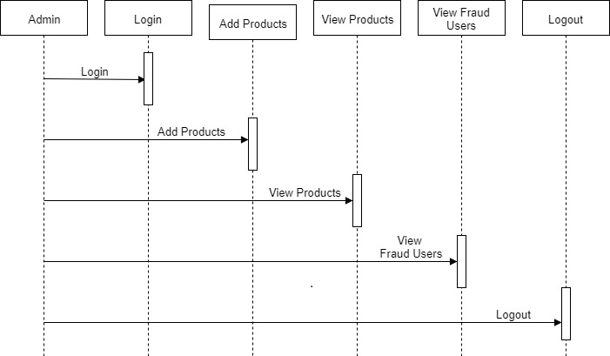

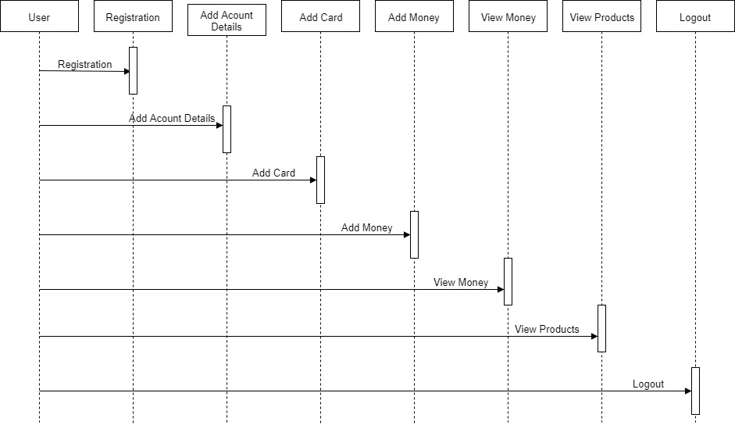

Figure 4.1.2: Sequence diagram

**4.1.3.** **CLASS DIAGRAM:**

In software engineering, a class diagram in the Unified Modeling Language (UML) is a type of static structure diagram that describes the structure of a system by showing the system's classes, their attributes, operations (or methods), and the relationships among the classes. It explains which class contains information.

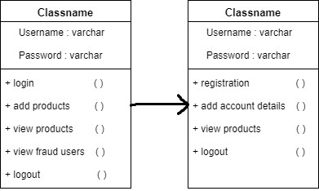

Figure 4.1.3: Class Diagram

**4.2.4 ACTIVITY DIAGRAM:**

Activity diagrams are graphical representations of workflows of stepwise activities and actions with support for choice, iteration and concurrency. In the Unified Modeling Language, activity diagrams can be used to describe the business and operational step-by-step workflows of components in a system. An activity diagram shows the overall flow of control.

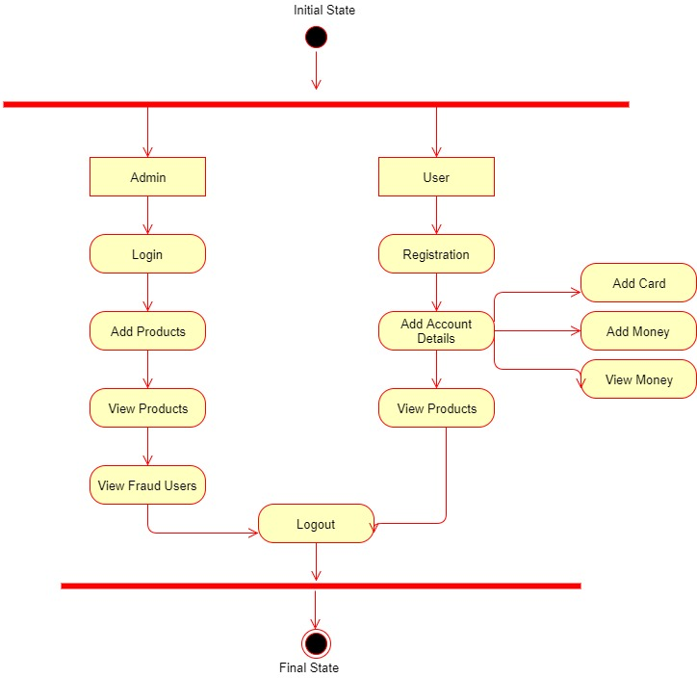

Figure 4.1.4: Activity Diagram

**TESTING &VALIDATION**

**INTRODUCTION:**

Testing is the debugging program is one of the most critical aspects of the computer programming triggers, without programming that works, the system would never produce an output of which it was designed. Testing is best performed when user development is asked to assist in identifying all errors and bugs. The sample data are used for testing. It is not quantity but quality of the data used the matters of testing. Testing is aimed at ensuring that the system was accurately an efficiently before live operation commands.

Testing objectives:

The main objective of testing is to uncover a host of errors, systematically and with minimum effort and time. Stating formally, we can say, testing is a process of executing a program with intent of finding an error.

1. A successful test is one that uncovers an as yet undiscovered error.
2. A good test case is one that has probability of finding an error, if it exists.
3. The test is inadequate to detect possibly present errors.
4. The software more or less confirms to the quality and reliable standards.

**5.2. Levels of Testing:**

Code testing:

This examines the logic of the program. For example, the logic for updating various sample data and with the sample files and directories were tested and verified.

Specification Testing:

Executing this specification starting what the program should do and how it should performed under various conditions. Test cases for various situation and combination of conditions in all the modules are tested.

Unit testing:

In the unit testing we test each module individually and integrate with the overall system. Unit testing focuses verification efforts on the smallest unit of software design in the module. This is also known as module testing. The module of the system is tested separately. This testing is carried out during programming stage itself. In the testing step each module is found to work satisfactorily as regard to expected output from the module. There are some validation checks for fields also. For example the validation check is done for varying the user input given by the user which validity of the data entered. It is very easy to find error debut the system.

Each Module can be tested using the following two Strategies:

1. Black Box Testing
2. White Box Testing

**BLACK BOX TESTING**

What is Black Box Testing?

Black box testing is a software testing techniques in which functionality of the software under test (SUT) is tested without looking at the internal code structure, implementation details and knowledge of internal paths of the software. This type of testing is based entirely on the software requirements and specifications.

In Black Box Testing we just focus on inputs and output of the software system without bothering about internal knowledge of the software program.

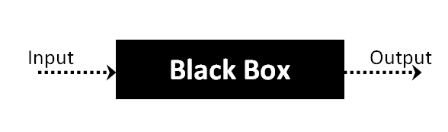

The above Black Box can be any software system you want to test. For example : an operating system like Windows, a website like Google ,a database like Oracle or even your own custom application. Under Black Box Testing , you can test these applications by just focusing on the inputs and outputs without knowing their internal code implementation.

Black box testing - Steps

Here are the generic steps followed to carry out any type of Black Box Testing.

* Initially requirements and specifications of the system are examined.
* Tester chooses valid inputs (positive test scenario) to check whether SUT processes them correctly. Also some invalid inputs (negative test scenario) are chosen to verify that the SUT is able to detect them.
* Tester determines expected outputs for all those inputs.
* Software tester constructs test cases with the selected inputs.
* The test cases are executed.
* Software tester compares the actual outputs with the expected outputs.
* Defects if any are fixed and re-tested.

Types of Black Box Testing

There are many types of Black Box Testing but following are the prominent ones -

* Functional testing – This black box testing type is related to functional requirements of a system; it is done by software testers.
* Non-functional testing – This type of black box testing is not related to testing of a specific functionality, but non-functional requirements  such as performance, scalability, usability.
* Regression testing – Regression testing is done  after code fixes , upgrades or any other system maintenance to check the new code has not affected the existing code.

**WHITE BOX TESTING**

White Box Testing is the testing of a software solution's internal coding and infrastructure. It focuses primarily on strengthening security, the flow of inputs and outputs through the application, and improving design and usability. White box testing is also known as clear, open, structural, and glass box testing.

It is one of two parts of the "box testing" approach of software testing. Its counter-part, black box testing, involves testing from an external or end-user type perspective. On the other hand, White box testing is based on the inner workings of an application and revolves around internal testing. The term "white box" was used because of the see-through box concept. The clear box or white box name symbolizes the ability to see through the software's outer shell (or "box") into its inner workings. Likewise, the "black box" in "black box testing" symbolizes not being able to see the inner workings of the software so that only the end-user experience can be tested

## What do you verify in White Box Testing?

White box testing involves the testing of the software code for the following:

* Internal security holes
* Broken or poorly structured paths in the coding processes
* The flow of specific inputs through the code
* Expected output
* The functionality of conditional loops
* Testing of each statement, object and function on an individual basis

The testing can be done at system, integration and unit levels of software development. One of the basic goals of whitebox testing is to verify a working flow for an application. It involves testing a series of predefined inputs against expected or desired outputs so that when a specific input does not result in the expected output, you have encountered a bug.

## How do you perform White Box Testing?

  To give you a simplified explanation of white box testing, we have divided it into **two basic steps**. This is what testers do when testing an application using the white box testing technique:

**STEP 1) UNDERSTAND THE SOURCE CODE**

The first thing a tester will often do is learn and understand the source code of the application. Since white box testing involves the testing of the inner workings of an application, the tester must be very knowledgeable in the programming languages used in the applications they are testing. Also, the testing person must be highly aware of secure coding practices. Security is often one of the primary objectives of testing software. The tester should be able to find security issues and prevent attacks from hackers and naive users who might inject malicious code into the application either knowingly or unknowingly.

**Step 2) CREATE TEST CASES AND EXECUTE**

The second basic step to white box testing involves testing the application’s source code for proper flow and structure. One way is by writing more code to test the application’s source code. The tester will develop little tests for each process or series of processes in the application. This  method requires that the tester must have intimate knowledge of the code and is often done by the developer. Other methods include manual testing, trial and error testing and the use of testing tools as we will explain further on in this article.

**System testing:**

Once the individual module testing is completed, modules are assembled and integrated to perform as a system. The top down testing, which began from upper level to lower level module, was carried out to check whether the entire system is performing satisfactorily.

There are three main kinds of System testing:

1. Alpha Testing
2. Beta Testing
3. Acceptance Testing

Alpha Testing:

This refers to the system testing that is carried out by the test team with the Organization.

Beta Testing:

This refers to the system testing that is performed by a selected group of friendly customers

Acceptance Testing:

This refers to the system testing that is performed by the customer to determine whether or not to accept the delivery of the system.

Integration Testing:

Data can be lost across an interface, one module can have an adverse effort on the other sub functions, when combined, may not produce the desired major functions. Integrated testing is the systematic testing for constructing the uncover errors within the interface. The testing was done with sample data. The developed system has run successfully for this sample data. The need for integrated test is to find the overall system performance.

Output testing:

After performance of the validation testing, the next step is output testing. The output displayed or generated by the system under consideration is tested by asking the user about the format required by system. The output format on the screen is found to be correct as format was designed in the system phase according to the user needs. Hence the output testing does not result in any correction in the system.

Test plan:

The test-plan is basically a list of testcases that need to be run on the system. Some of the testcases can be run independently for some components (report generation from the database, for example, can be tested independently) and some of the testcases require the whole system to be ready for their execution. It is better to test each component as and when it is ready before integrating the components. It is important to note that the testcases cover all the aspects of the system (ie, all the requirements stated in the RS document).

**CHAPTER: 6**

**SCREEN SHOTS**

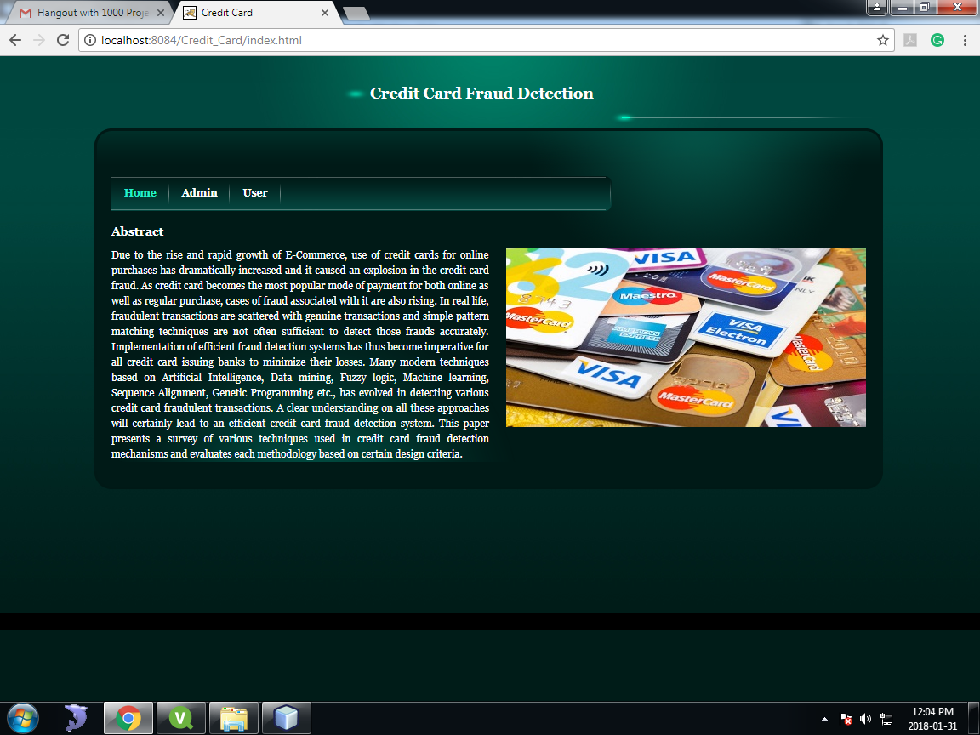

Fig: Home Page

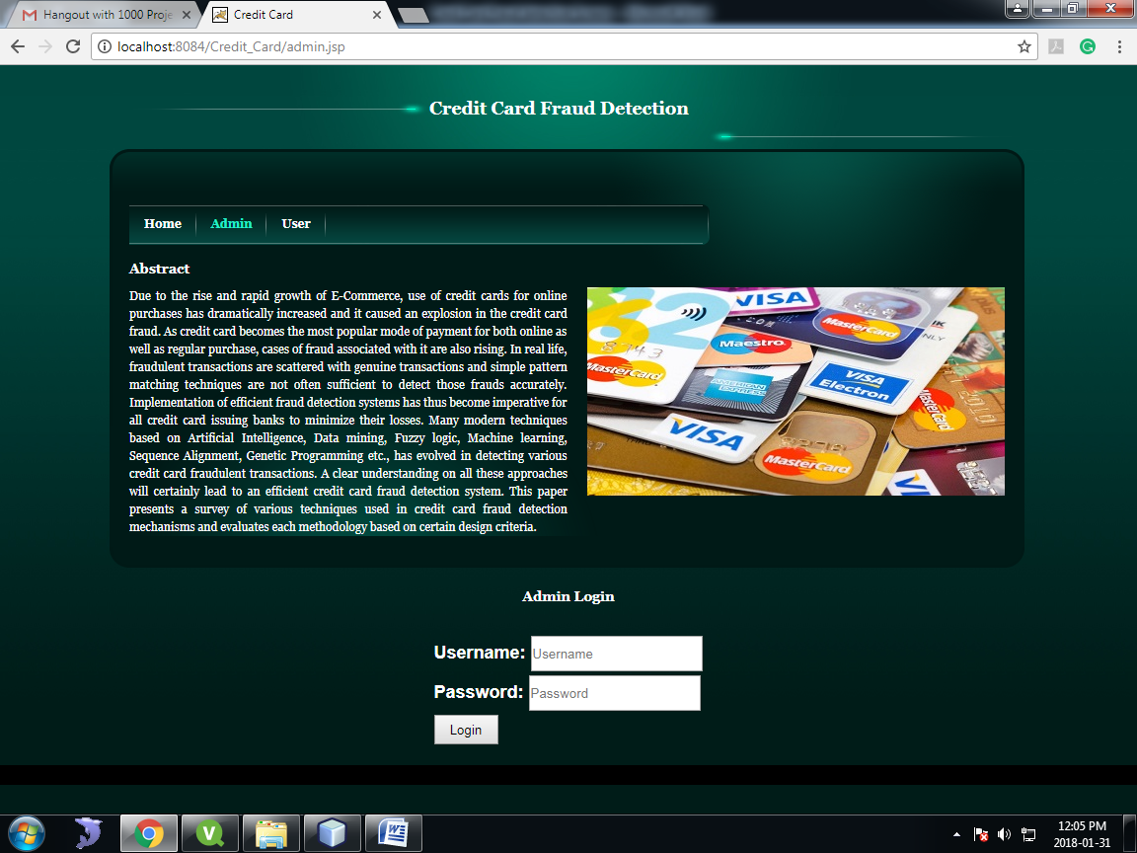

Fig: Admin Login

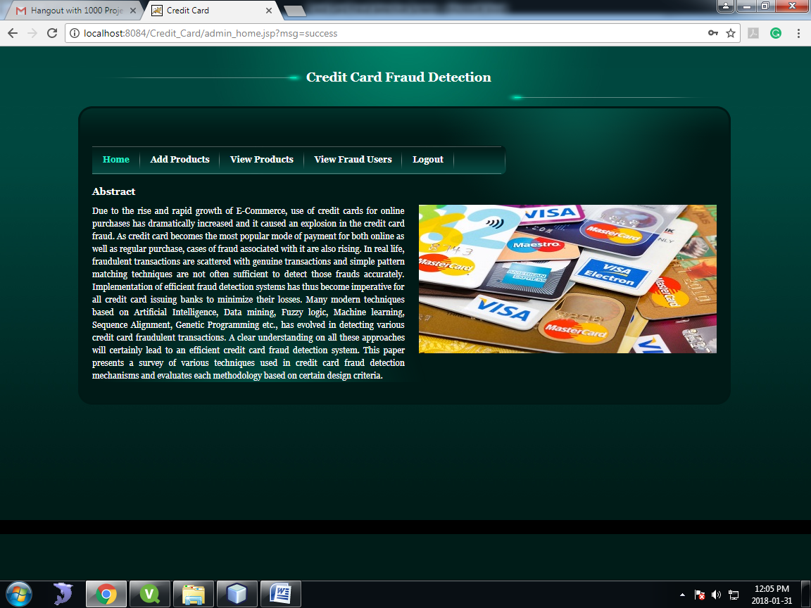

Fig: Admin Home

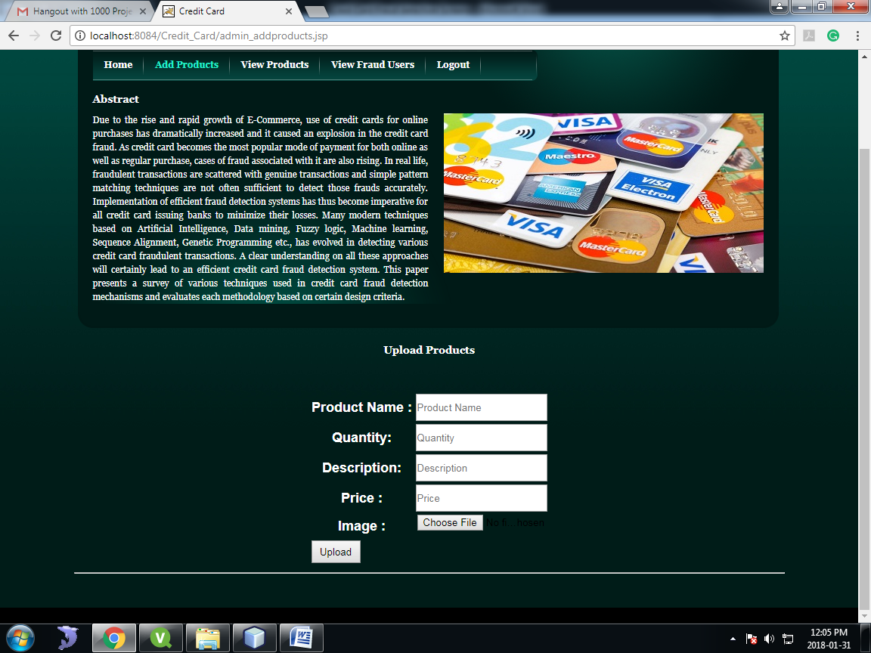

Fig: Add Products

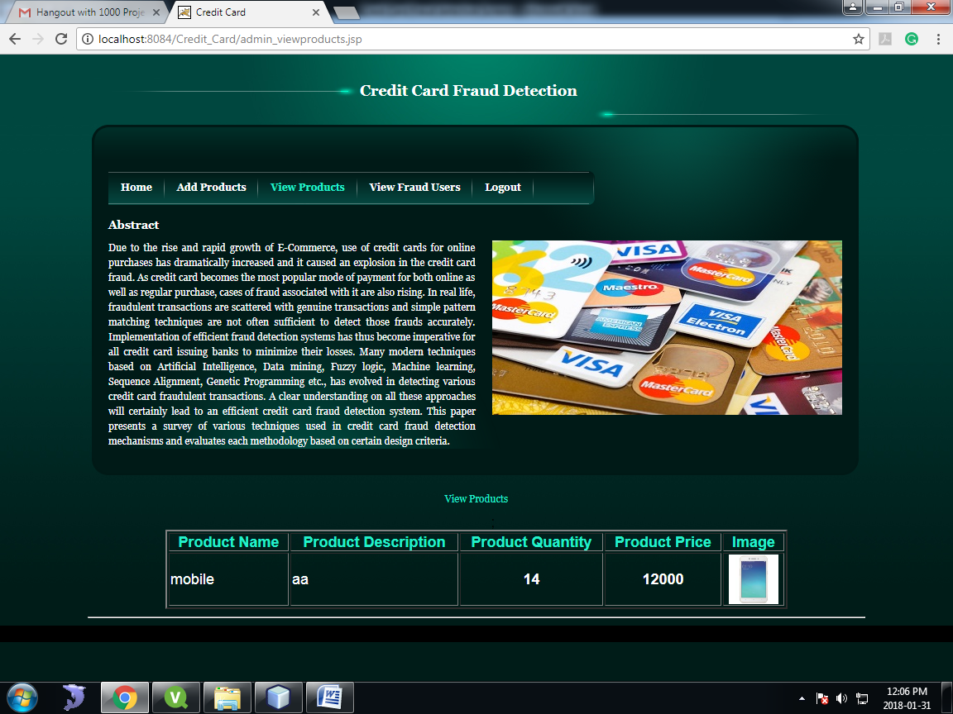

Fig: View Products

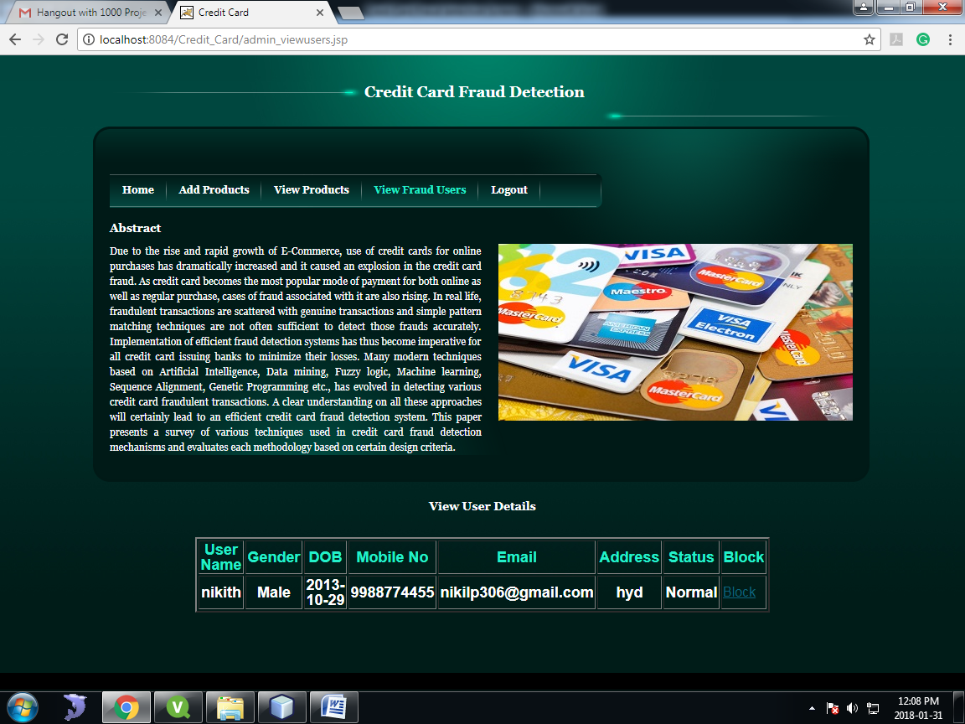

Fig: View Fraud Users

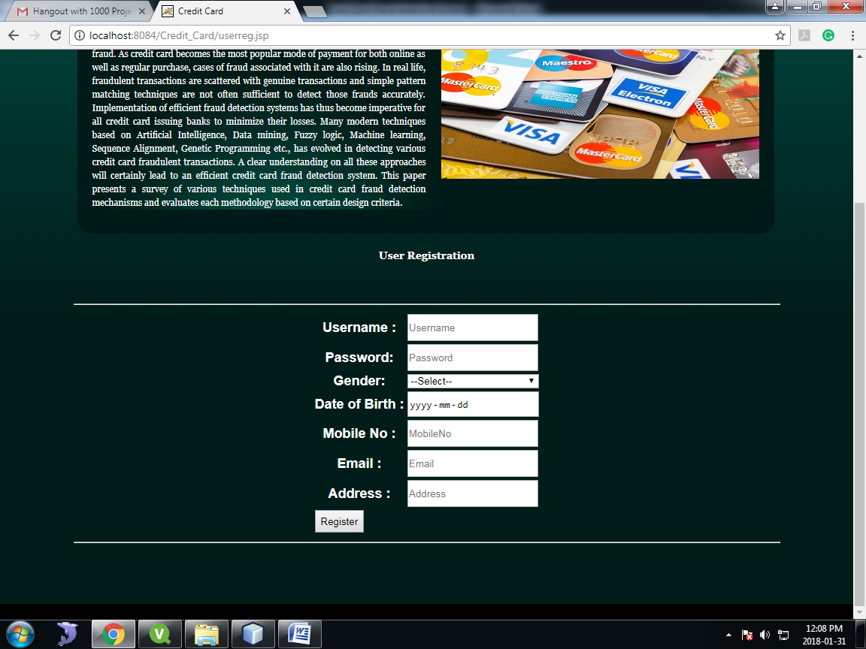

Fig: User Registration

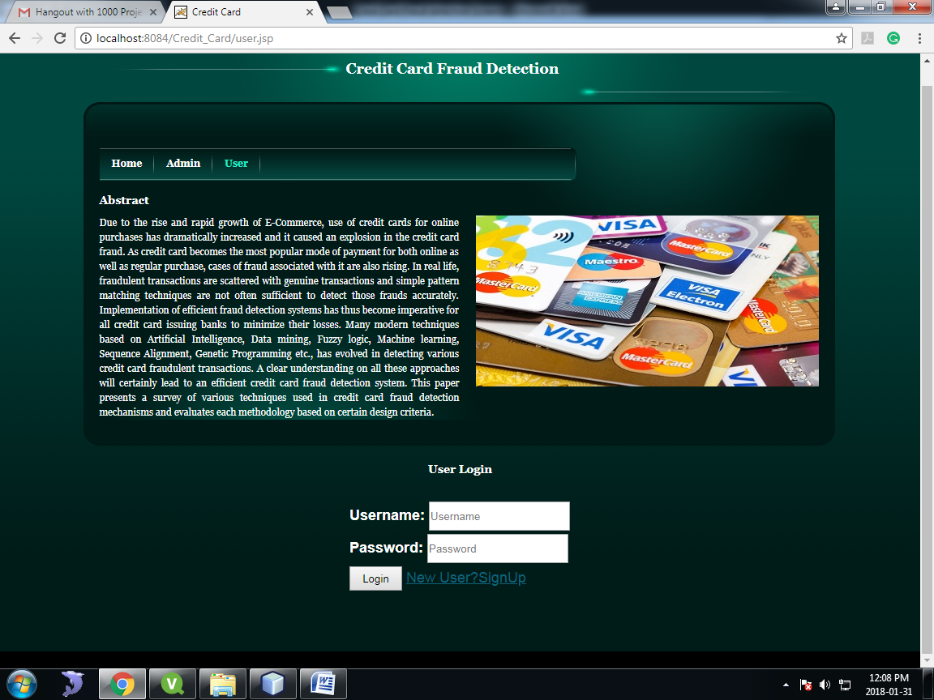

Fig: User Login

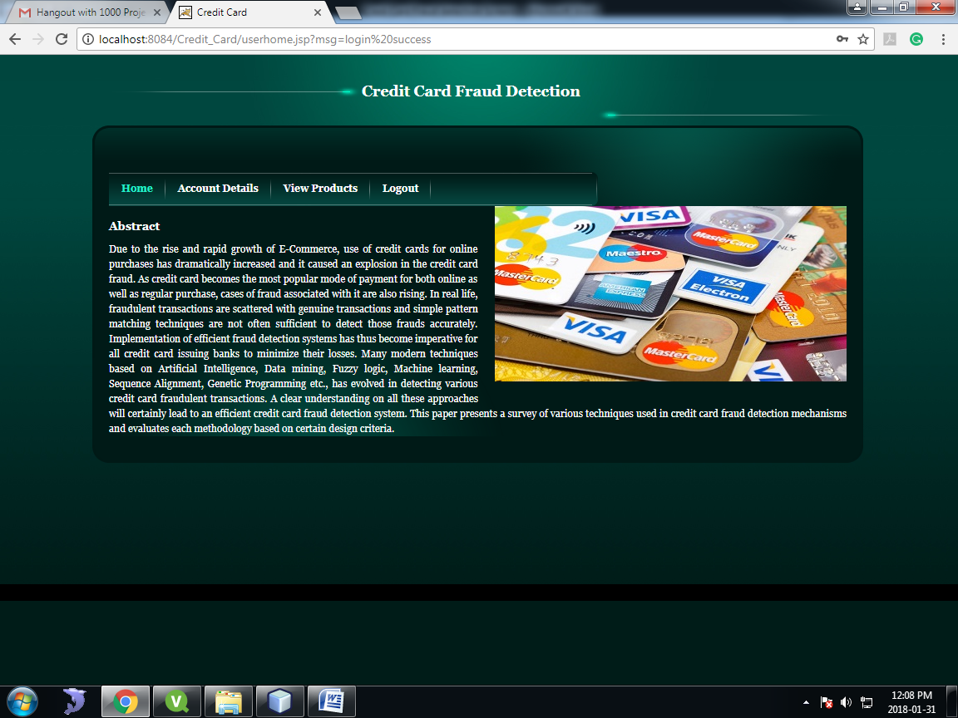

Fig: User Home

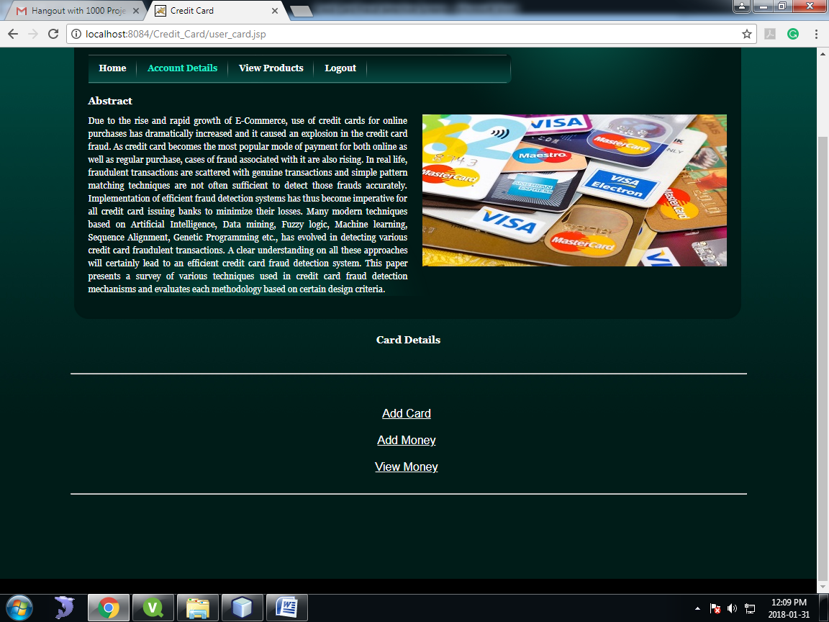

Fig: View Account Details

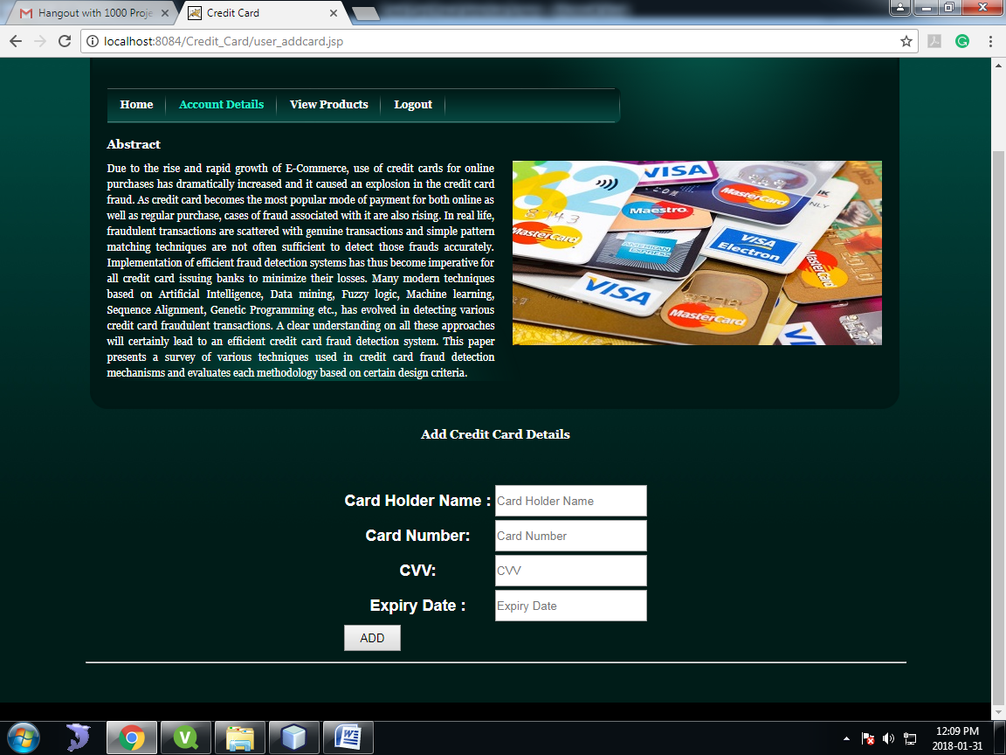

Fig: Add Card Details

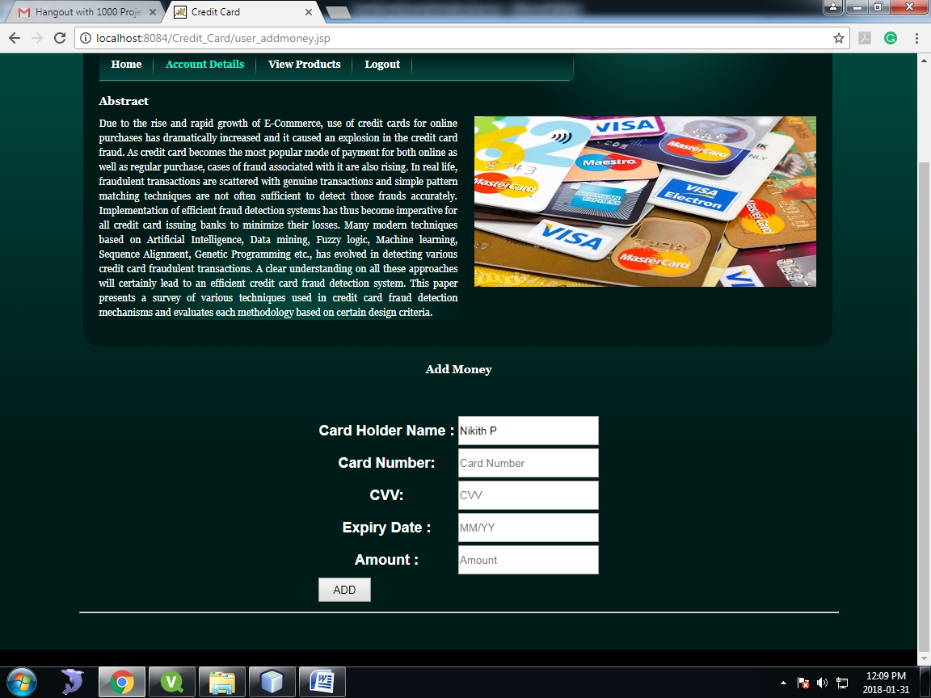

Fig: Add Money to Card

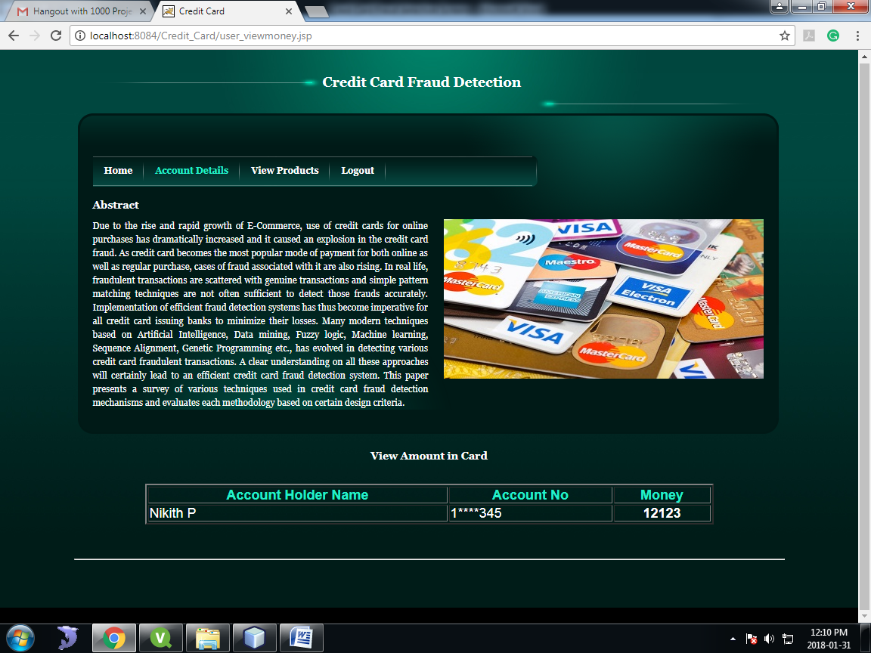

Fig: View Money

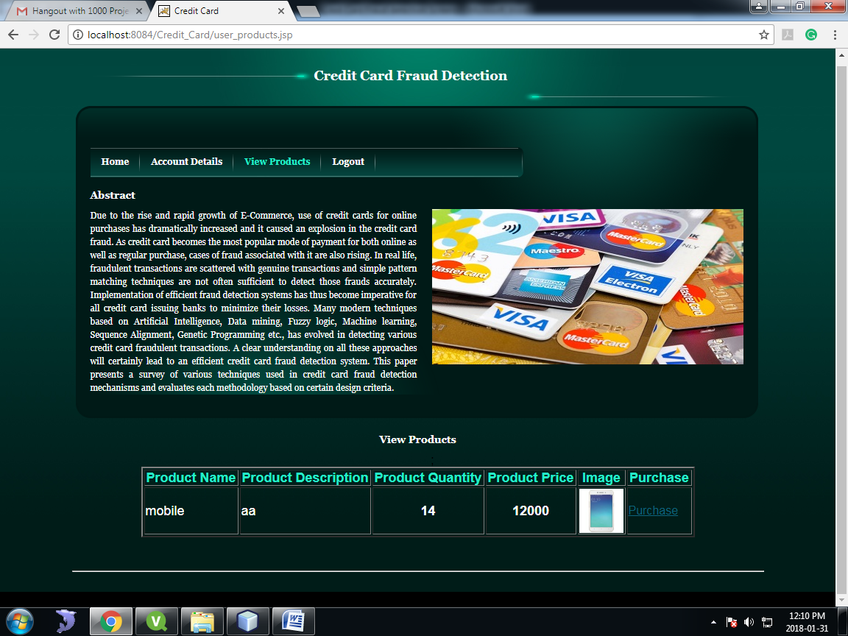

Fig: View Products

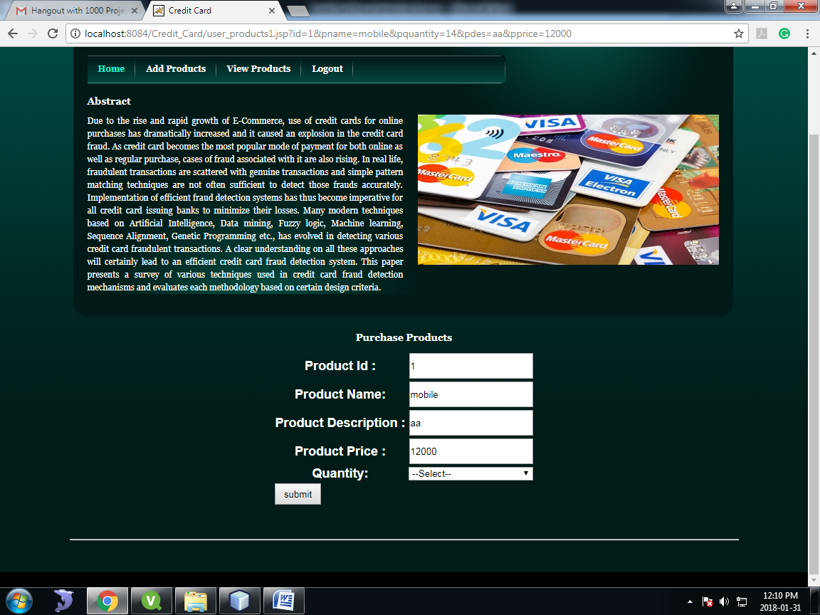

Fig: Select Quantity

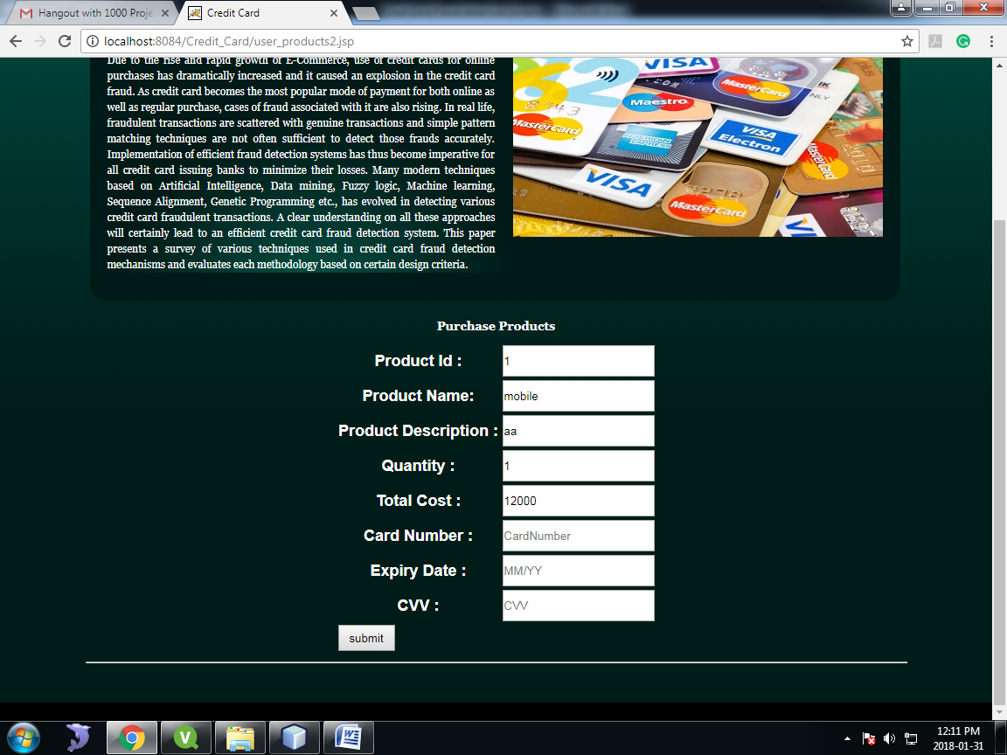

Fig: Enter Account Details

**REFERENCE:**

S.Benson Edwin Raj, A. Annie Portia, “Analysis on Credit Card Fraud Detection Methods”, IEEE International Conference on Computer, Communication and Electrical Technology, **IEEE March 2011.**